**Overview of Existing Hosting Platforms**

**Grid Computing**

Grid Computing can be defined as a network of computers working together to perform a task that would rather be difficult for a single machine. All machines on that network work under the same protocol to act like a virtual supercomputer. The task that they work on may include analysing huge datasets or simulating situations which require high computing power. Computers on the network contribute resources like processing power and storage capacity to the network.

Grid Computing is a subset of distributed computing, where a virtual super computer comprises of machines on a network connected by some bus, mostly Ethernet or sometimes the Internet. It can also be seen as a form of Parallel Computing where instead of many CPU cores on a single machine, it contains multiple cores spread across various locations. The concept of grid computing isn’t new, but it is not yet perfected as there are no standard rules and protocols established and accepted by people.

**Working of Grid Computing**

A Grid computing network mainly consists of these three types of machines

1. **Control Node**

A computer, usually a server or a group of servers which administrates the whole network and keeps the account of the resources in the network pool.

1. **Provider**

The computer which contributes it’s resources in the network resource pool.

1. **User**

The computer that uses the resources on the network is called user.

When a computer makes a request for resources to the control node, control node gives the user access to the resources available on the network. When it is not in use it should ideally contribute it’s resources to the network. Hence a normal computer on the node can swing in between being a user or a provider based on it’s needs. The nodes may consist of machines with similar platforms using same OS called homogenous networks, else machines with different platforms running on various different OS called heterogeneous networks. This is the distinguishing part of grid computing from other distributed computing architectures.

For controlling the network and its resources a software/networking protocol is used generally known as Middleware. This is responsible for administrating the network and the control nodes are merely it’s executors. As a grid computing system should use only unused resources of a computer, it is the job of the control node that any provider is not overloaded with tasks.

Another job of the middleware is to authorize any process that is being executed on the network. In a grid computing system, a provider gives permission to the user to run anything on it’s computer, hence it is a huge security threat for the network. Hence a middleware should ensure that there is no unwanted task being executed on the network.

The meaning of the term Grid Computing has changed over the years, according to “The Grid: Blueprint for a new computing infrastructure” by Ian Foster and Carl Kesselman published in 1999, the idea was to consume computing power like electricity is consumed from a power grid. This idea is similar to current concept of cloud computing, whereas now grid computing is viewed as a distributed collaborative network. Currently grid computing is being used in various institutions to solve a lot of mathematical, analytical and physics problems.

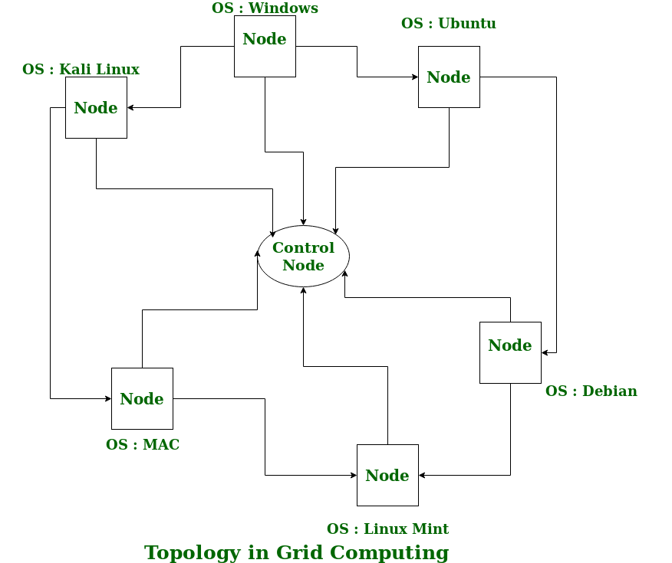

Figure 1Topology in Grid Computing

**How grid computing works?**

A scientist studying proteins logs into a computer and uses an entire network of computers to analyze data. A businessman accesses his company's network through a PDA in order to forecast the future of a particular stock. An Army official accesses and coordinates computer resources on three different military networks to formulate a battle strategy. All of these scenarios have one thing in common: They rely on a concept called grid computing.

At its most basic level, grid computing is a computer network in which each computer's resources are shared with every other computer in the system. Processing power, memory and data storage are all community resources that authorized users can tap into and leverage for specific tasks. A grid computing system can be as simple as a collection of similar computers running on the same operating system or as complex as inter-networked systems comprised of every computer platform you can think of.

The grid computing concept isn't a new one. It's a special kind of distributed computing. In distributed computing, different computers within the same network share one or more resources. In the ideal grid computing system, every resource is shared, turning a computer network into a powerful supercomputer. With the right user interface, accessing a grid computing system would look no different than accessing a local machine's resources. Every authorized computer would have access to enormous processing power and storage capacity.

Though the concept isn't new, it's also not yet perfected. Computer scientists, programmers and engineers are still working on creating, establishing and implementing standards and protocols. Right now, many existing grid computer systems rely on proprietary software and tools. Once people agree upon a reliable set of standards and protocols, it will be easier and more efficient for organizations to adopt the grid computing model.

**Advantages of Grid Computing**

1. It is not centralized, as there are no servers required, except the control node which is just used for controlling and not for processing.
2. Multiple heterogeneous machines i.e. machines with different Operating Systems can use a single grid computing network.
3. Tasks can be performed parallel across various physical locations and the users don’t have to pay for it(with money).

**RELEVANT READING MATERIAL AND REFERENCES:**

**Source Notes:**

https://www.geeksforgeeks.org/grid-computing/

<https://www.javatpoint.com/cloud-computing-vs-grid-computing>

Video Lectures:

<https://www.youtube.com/watch?v=7ppFIZAexYc>

Text Book Reading:

1. Buyya, Rajkumar, James Broberg, and Andrzej M. Goscinski, eds. Cloud computing: Principles and paradigms. Vol. 87. John Wiley & Sons, 2010.

2. Miller, Michael. Cloud computing: Web-based applications that change the way you work and collaborate online. Que publishing, 2008

**In addition: PPT can be also be given.**

**Lecture 2**

**Grid Computing Vs Cloud Computing**

**Cloud Computing:**   
Cloud Computing is a Client-server computing architecture. In cloud computing, resources are used in centralized pattern and cloud computing is a high accessible service. It is a pay and use business means, in cloud computing, the users pay for the use

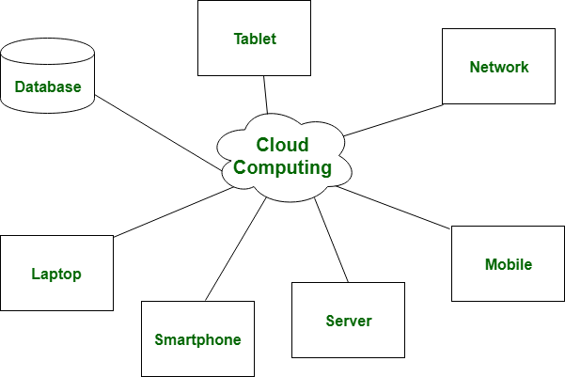

**Grid Computing:**   
Grid Computing is a Distributed computing architecture. In grid computing, resources are used in collaborative pattern, and also in grid computing, the users do not pay for use.

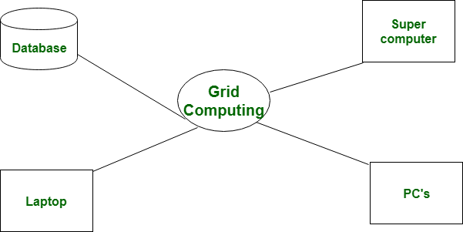

|  |  |  |
| --- | --- | --- |
| **S.No** | **Cloud Computing** | **Grid Computing** |
| 1. | Cloud computing is a Client-server computing architecture. | While it is a Distributed computing architecture. |
| 2. | Cloud computing is a centralized executive. | While grid computing is a decentralized executive. |
| 3. | In cloud computing, resources are used in centralized pattern. | While in grid computing, resources are used in collaborative pattern. |
| 4. | It is more flexible than grid computing. | While it is less flexible than cloud computing. |
| 5. | In cloud computing, the users pay for the use. | While in grid computing, the users do not pay for use. |
| 6. | Cloud computing is a high accessible service. | While grid computing is a low accessible service. |
| |  | | --- | | 7. | |  | | It is highly scalable as compared to grid computing. | While grid computing is low scalable in comparison to cloud computing. |
| 8. | It can be accessed through standard web protocols. | While it is accessible through grid middleware. |

**RELEVANT READING MATERIAL AND REFERENCES:**

**Source Notes:**

<https://www.geeksforgeeks.org/difference-between-cloud-computing-and-grid-computing/>

https://www.javatpoint.com/cloud-computing-vs-grid-computing

Video Lectures:

https://www.youtube.com/watch?v=XvkhMxlwsww

Text Book Reading:

1. Buyya, Rajkumar, James Broberg, and Andrzej M. Goscinski, eds. Cloud computing: Principles and paradigms. Vol. 87. John Wiley & Sons, 2010.

Lecture 3

**Utility Computing**

Utility computing allow the user to pay per use means whatever they are using only for that they have to pay. It is a plug in that needs to be managed by the organizations on deciding what type of services has to be deployed from the cloud. Utility computing allows the user to think and implement the services according to them. Most organizations go for hybrid strategy that combines internal delivered services that are hosted or outsourced services.

Let's define utility computing this way: *Utility computing consists of a virtualized pool of IT resources that can be dynamically provisioned to ensure that these resources are easily and continually reallocated in a way that addresses the organization's changing business and service needs. These resources can be located anywhere and managed by anyone, and the usage of these resources can be tracked and billed down to the level of an individual user or group*.

There are three major reasons why utility computing will become significant in IT:

1. Promises to address pressing business needs, including making the business more agile, adaptive, and flexible; and, more importantly, able to treat IT as an increasingly variable cost. The aim of utility computing is to reduce IT costs.
2. Can be supplied in small, incremental bites that deliver fast, demonstrable, significant return on investment, so companies don't have to wait for the full implementation to achieve payoffs. Much shorter time to market.
3. Provides total flexibility in implementation, from in-house and self-managed to fully outsourced, with everything in-between—including a hybrid deployment model in which in-house capacity can be supplemented by third-party resources to handle peak needs.

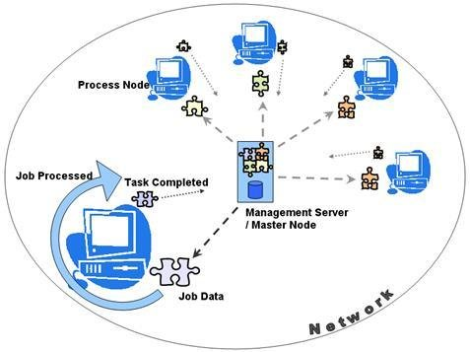

**Advantages and Disadvantages of utility computing**

For most clients, the biggest advantage of utility computing is convenience. The client doesn't have to buy all the hardware, software and licenses needed to do business. Instead, the client relies on another party to provide these services. The burden of maintaining and administering the system falls to the utility computing company, allowing the client to concentrate on other tasks.

Closely related to convenience is compatibility. In a large company with many departments, problems can arise with computing software. Each department might depend on different software suites. The files used by employees in one part of a company might be incompatible with the software used by employees in another part. Utility computing gives companies the option to subscribe to a single service and use the same suite of software throughout the entire client organization.

Cost can be either an advantage or disadvantage, depending on how the provider structures fees. Using a utility computing company for services can be less expensive than running computer operations in-house. As long as the utility computing company offers the client the services it needs to do business, there's no need for the client to look elsewhere. Most of the cost for maintenance becomes the responsibility of the provider, not the client. The client can choose to rely on simplified hardware, which is less expensive and can be easier to maintain.

However, in some cases what the client needs and what the provider offers aren't in alignment. If the client is a small business and the provider offers access to expensive supercomputers at a hefty fee, there's a good chance the client will choose to handle its own computing needs. Why pay a high service charge for something you don't need?

Another potential disadvantage is reliability. If a utility computing company is in financial trouble or has frequent equipment problems, clients could get cut off from the services for which they're paying. This spells trouble for both the provider and the client. If a utility computing company goes out of business, its clients could fall victim to the same fate. Clients might hesitate to hand over duties to a smaller company if it could mean losing data and other capabilities should the business suffer.

Utility computing systems can also be attractive targets for hackers. A hacker might want to access services without paying for them or snoop around and investigate client files. Much of the responsibility of keeping the system safe falls to the provider, but some of it also relies on the client's practices. If a company doesn't educate its workforce on proper access procedures, it's not hard for an intruder to find ways to invade a utility computing company's system.

One challenge facing utility computing services is educating consumers about the service. Awareness of utility computing isn't very widespread. It's hard to sell a service to a client if the client has never heard of it. Now that you've read this article, you're ahead of the game.

As utility computing companies offer more comprehensive and sophisticated services, we may see more corporations choosing to use their services. Eventually, it's possible that computers in data centers miles from your home or office will handle all your computational needs for you.

**How utility computing works?**

The principle of utility computing is very simple: One company pays another company for computing services. The services might include hardware rental, data storage space, use of specific computer applications or access to computer processing power. It all depends on what the client wants and what the utility computing company can offer.

Many utility computing companies offer bundles or packages of resources. A comprehensive package might include all of the following:

Computer hardware, including servers, CPUs, monitors, input devices and network cables.

Internet access, including Web servers and browsing software.

* Software applications that run the entire gamut of computer programs. They could include word processing programs, e-mail clients, project-specific applications and everything in between. Industry experts call this particular kind of business "Software as a Service" (SaaS).
* Access to the processing power of a supercomputer. Some corporations have hefty computational requirements. For example, a financial company might need to process rapidly-changing data gathered from the stock market. While a normal computer might take hours to process complicated data, a supercomputer could complete the same task much more quickly.
* The use of a grid computing system. A grid computing system is a network of computers running special software called middleware. The middleware detects idle CPU processing power and allows an application running on another computer to take advantage of it. It's useful for large computational problems that can be divided into smaller chunks.
* Off-site data storage, which is also called cloud storage. There are many reasons a company might want to store data off-site. If the company processes a lot of data, it might not have the physical space to hold the data servers it needs. An off-site backup is also a good way to protect information in case of a catastrophe. For example, if the company's building were demolished in a fire, its data would still exist in another location.

Utility computing rates vary depending on the utility computing company and the requested service. Usually, companies charge clients based on service usage rather than a flat fee. The more a client uses services, the more fees it must pay. Some companies bundle services together at a reduced rate, essentially selling computer services in bulk.

**RELEVANT READING MATERIAL AND REFERENCES:**

<https://www.eukhost.com/blog/webhosting/what-is-utility-computing/>

Online Notes: <https://www.tutorialspoint.com/cloud_computing/cloud_computing_tutorial.pdf>

Video Lectures:

https://www.youtube.com/watch?v=qnFKA8UooTQ

Text Book Reading:

1. Buyya, Rajkumar, James Broberg, and Andrzej M. Goscinski, eds. Cloud computing: Principles and paradigms. Vol. 87. John Wiley & Sons, 2010.

2. Miller, Michael. Cloud computing: Web-based applications that change the way you work and collaborate online. Que publishing, 2008

**In addition: PPT can be also be given.**

Lecture 4

**Introduction to cloud computing**

**Cloud Computing**

In Simplest terms, cloud computing means storing and accessing the data and programs on remote servers that are hosted on internet instead of computer’s hard drive or local server. Cloud computing is also referred as Internet based computing.

In other words, we can say that Cloud computing means on demand delivery of IT resources via the internet with pay-as-you-go pricing. It provides a solution of IT infrastructure in low cost.

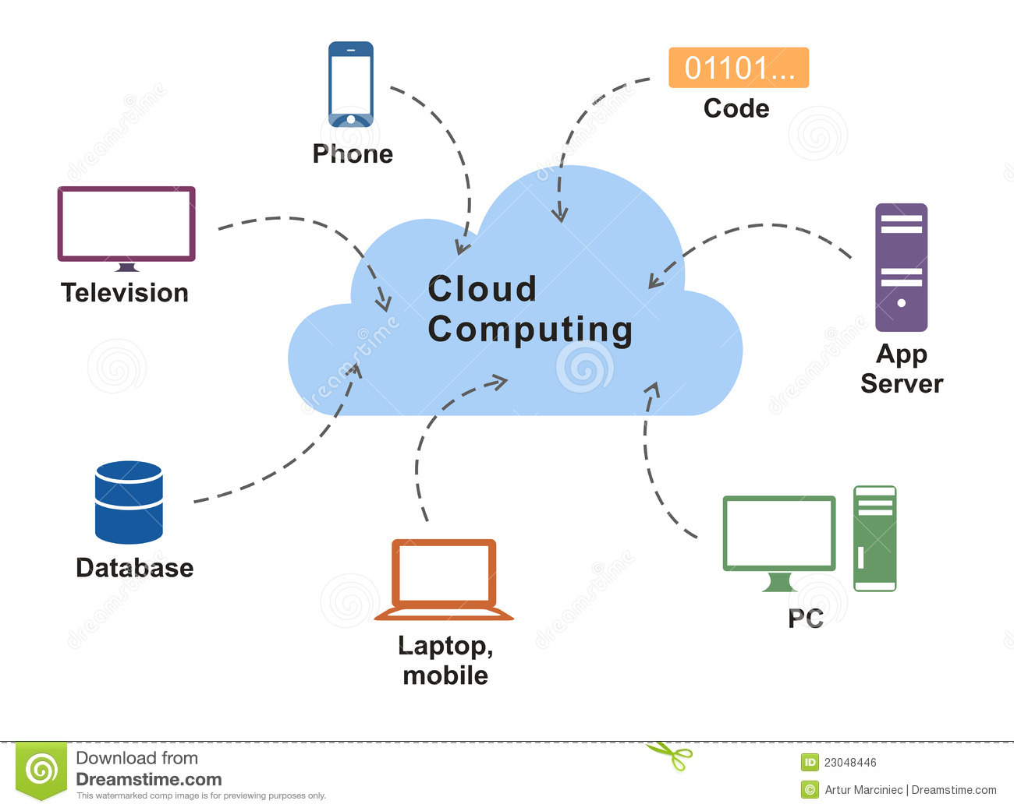

**History of Cloud Computing**

Before emerging the cloud computing, there was Client/Server computing which is basically a centralized storage in which all the software applications, all the data and all the controls are resided on the server side.

If a single user wants to access specific data or run a program, he/she need to connect to the server and then gain appropriate access, and then he/she can do his/her business. Then after, distributed computing came into picture, where all the computers are networked together and share their resources when needed.

On the basis of above computing, there was emerged of cloud computing concepts that later implemented.

At around in 1961, John MacCharty suggested in a speech at MIT that computing can be sold like a utility, just like a water or electricity. It was a brilliant idea, but like all brilliant ideas, it was ahead if its time, as for the next few decades, despite interest in the model, the technology simply was not ready for it.

But of course, time has passed and the technology caught that idea and after few years we mentioned that:

*In 1999,***Salesforce.com***started delivering of applications to users using a simple website*. The applications were delivered to enterprises over the Internet, and this way the dream of computing sold as utility were true.

*In 2002,***Amazon***started Amazon Web Services*, providing services like storage, computation and even human intelligence. However, only starting with the launch of the Elastic Compute Cloud in 2006 a truly commercial service open to everybody existed.

*In 2009,***Google Apps***also started to provide cloud computing enterprise applications.*

Of course, all the big players are present in the cloud computing evolution, some were earlier, some were later. *In 2009,***Microsoft***launched Windows Azure*, and companies like Oracle and HP have all joined the game. This proves that today, cloud computing has become mainstream.

**Need of Cloud Computing**

Actually, Small as well as some large IT companies follows the traditional methods to provide the IT infrastructure. That means for any IT company, we need a Server Room that is the basic need of IT companies. In that server room, there should be a database server, mail server, networking, firewalls, routers, modem, switches, QPS (Query Per Second means how much queries or load will be handled by the server), configurable system, high net speed and the maintenance engineers. To establish such IT infrastructure, we need to spend lots of money. To overcome all these problems and to reduce the IT infrastructure cost, Cloud Computing comes into existence.

**Characteristics of Cloud Computing**

There are following characteristics of Cloud Computing.

**1) Agility**

The cloud works in the distributed computing environment. It shares resources among users and works very fast.

**2) High availability and reliability**

Availability of servers is high and more reliable, because chances of infrastructure failure are minimal.

**3) High Scalability**

Means "on-demand" provisioning of resources on a large scale, without having engineers for peak loads.

**4) Multi-Sharing**

With the help of cloud computing, multiple users and applications can work more efficiently with cost reductions by sharing common infrastructure.

**5) Device and Location Independence**

Cloud computing enables the users to access systems using a web browser regardless of their location or what device they use e.g. PC, mobile phone etc. As infrastructure is off-site (typically provided by a third-party) and accessed via the Internet, users can connect from anywhere.

**6) Maintenance**

Maintenance of cloud computing applications is easier, since they do not need to be installed on each user's computer and can be accessed from different places. So, it reduces the cost also.

**7) Low Cost**

By using cloud computing, the cost will be reduced because to take the services of cloud computing, IT company need not to set its own infrastructure and pay-as-per usage of resources.

**8) Services in pay-per-use mode**

Application Programming Interfaces (APIs) are provided to the users so that they can access services on the cloud by using these APIs and pay the charges as per the usage of services.

**Applications of Cloud Computing in real-world:**

[Cloud Service Providers (CSP)](https://www.geeksforgeeks.org/top-5-cloud-platform-service-providers-in-2020/)are providing many types of cloud services and now if we sill cloud computing has touched every sector by providing various cloud applications. Sharing and managing resources is easy in cloud computing that’s why it is one of the dominant fields of computing. These properties have made it an active component in many fields. Now let’s know some of the real-world applications of cloud computing.

1. **Online**Data Storage**:**  
   Cloud computing allows storing data like files, images, audios, and videos, etc on the cloud storage. The organization need not set physical storage systems to store a huge volume of business data which costs so high nowadays. As they are growing technologically, data generation is also growing with respect to time, and storing that becoming problem. In that situation, Cloud storage is providing this service to store and access data any time as per requirement.
2. **Backup and Recovery:**  
   Cloud vendors provide security from their side by storing safe to the data as well as providing a backup facility to the data. They offer various recovery application for retrieving the lost data. In the traditional way backup of data is a very complex problem and also it is very difficult sometimes impossible to recover the lost data. But cloud computing has made backup and recovery applications very easy where there is no fear of running out of backup media or loss of data.
3. **Big Data Analysis:**  
   We know the volume of big data is so high where storing that in traditional data management system for an organization is impossible. But cloud computing has resolved that problem by allowing the organizations to store their large volume of data in cloud storage without worrying about physical storage. Next comes analyzing the raw data and finding out insights or useful information from it is a big challenge as it requires high-quality tools for data analytics. Cloud computing provides the biggest facility to organizations in terms of storing and analyzing big data.
4. Testing**and Development:**  
   Setting up the platform for development and finally performing different types of testing to check the readiness of the product before delivery requires different types of IT resources and infrastructure. But Cloud computing provides the easiest approach for development as well as testing even if deployment by using their IT resources with minimal expenses. Organizations find it more helpful as they got scalable and flexible cloud services for product development, testing, and deployment.
5. Anti-Virus**Applications:**  
   Previously, organizations were installing antivirus software within their system even if we will see we personally also keep antivirus software in our system for safety from outside cyber threats. But nowadays cloud computing provides cloud antivirus software which means the software is stored in the cloud and monitors your system/organization’s system remotely. This antivirus software identifies the security risks and fixes them. Sometimes also they give a feature to download the software.
6. **Ecommerce Application:**  
   Cloud-based e-commerce allows responding quickly to the opportunities which are emerging. Users respond quickly to the market opportunities as well as the traditional e-commerce responds to the challenges quickly. Cloud-based e-commerce gives a new approach to doing business with the minimum amount as well as minimum time possible. Customer data, product data, and other operational systems are managed in cloud environments.
7. **Cloud computing in education:**  
   Cloud computing in the education sector brings an unbelievable change in learning by providing e-learning, online distance learning platforms, and student information portals to the students. It is a new trend in education that provides an attractive environment for learning, teaching, experimenting, etc to students, faculty members, and researchers. Everyone associated with the field can connect to the cloud of their organization and access data and information from there.
8. **Cloud Computing in Medical Fields:**  
   In the medical field also nowadays cloud computing is used for storing and accessing the data as it allows to store data and access it through the internet without worrying about any physical setup. It facilitates easier access and distribution of information among the various medical professional and the individual patients. Similarly, with help of cloud computing offsite buildings and treatment facilities like labs, doctors making emergency house calls and ambulances information, etc can be easily accessed and updated remotely instead of having to wait until they can access a hospital computer.

**RELEVANT READING MATERIAL AND REFERENCES:**

**Source Notes:**

[**https://www.guru99.com/cloud-computing-for-beginners.html**](https://www.guru99.com/cloud-computing-for-beginners.html)

[**https://www.javatpoint.com/introduction-to-cloud-computing**](https://www.javatpoint.com/introduction-to-cloud-computing)

**https://www.geeksforgeeks.org/real-world-applications-of-cloud-computing/**

Video Lectures:

<https://www.youtube.com/watch?v=ajfL2fB-c3I&feature=emb_title>

<https://www.youtube.com/watch?v=u7hrUZHfKes>

https://www.youtube.com/watch?app=desktop&v=JBo2vV5SpOM&list=PLWPirh4EWFpENQHvu9aBdLfZEDotdAdy1

Text Book Reading:

1. Buyya, Rajkumar, James Broberg, and Andrzej M. Goscinski, eds. Cloud computing: Principles and paradigms. Vol. 87. John Wiley & Sons, 2010.

2. Miller, Michael. Cloud computing: Web-based applications that change the way you work and collaborate online. Que publishing, 2008

**In addition: PPT can be also be given.**

Lecture-5

**Cloud Computing Architecture**

As we know, cloud computing technology is used by both small and large organizations to **store the information** in cloud and **access** it from anywhere at anytime using the internet connection.

Cloud computing architecture is a combination of **service-oriented architecture** and **event-driven architecture**.

Cloud computing architecture is divided into the following two parts -

* Front End
* Back End

The below diagram shows the architecture of cloud computing -

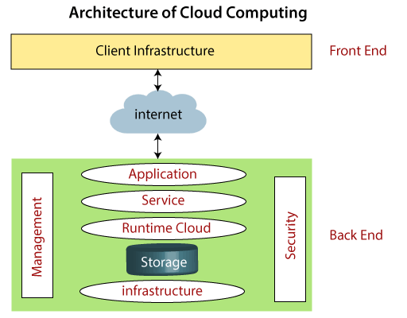

### **Front End**

The front end is used by the client. It contains client-side interfaces and applications that are required to access the cloud computing platforms. The front end includes web servers (including Chrome, Firefox, internet explorer, etc.), thin & fat clients, tablets, and mobile devices.

### **Back End**

The back end is used by the service provider. It manages all the resources that are required to provide cloud computing services. It includes a huge amount of data storage, security mechanism, virtual machines, deploying models, servers, traffic control mechanisms, etc.

**Hosting a Cloud**

There are three layers in cloud computing. Companies use these layers based on the service they provide.

* Infrastructure
* Platform
* Application

At the bottom is the foundation, the Infrastructure where the people start and begin to build. This is the layer where the cloud hosting lives.

Now, let’s have a look at hosting:

Let’s say you have a company and a website and the website has a lot of communications that are exchanged between members. You start with a few members talking with each other and then gradually the numbers of members increases.

As the time passes, as the number of members increases, there would be more traffic on the network and your server will get slow down. This would cause a problem.

A few years ago, the websites are put in the server somewhere, in this way you have to run around or buy and set number of servers. It costs a lot of money and takes lot of time. You pay for these servers when you are using and as well as when you are not using. This is called hosting.

This problem is overcome by cloud hosting. With Cloud Computing, you have access to computing power when you needed. Now, your website is put in the cloud server as you put it on dedicated server. People start visiting your website and if you suddenly need more computing power, you would scale up according to the need.

**Benefits of Cloud Hosting:**

1. **Scalability**
2. **Instant**
3. **Save Money**
4. **Reliability**
5. **Physical Security**

## **Components of Cloud Computing Architecture**

There are the following components of cloud computing architecture -

**1. Client Infrastructure**

Client Infrastructure is a Front-end component. It provides GUI (Graphical User Interface) to interact with the cloud.

**2. Application**

The application may be any software or platform that a client wants to access.

**3. Service**

A Cloud Services manages that which type of service you access according to the client’s requirement.

Cloud computing offers the following three type of services:

**i. Software as a Service (SaaS) –**It is also known as **cloud application services**. Mostly, SaaS applications run directly through the web browser means we do not require to download and install these applications. Some important example of SaaS is given below –

**Example:** Google Apps, Salesforce Dropbox, Slack, Hubspot, Cisco WebEx.

**ii. Platform as a Service (PaaS) –** It is also known as **cloud platform** **services**. It is quite similar to SaaS, but the difference is that PaaS provides a platform for software creation, but using SaaS, we can access software over the internet without the need of any platform.

**Example:** Windows Azure, Force.com, Magento Commerce Cloud, OpenShift.

**iii. Infrastructure as a Service (IaaS) –**It is also known as **cloud infrastructure services**. It is responsible for managing applications data, middleware, and runtime environments.

**Example:** Amazon Web Services (AWS) EC2, Google Compute Engine (GCE), Cisco Metapod.

**4. Runtime Cloud**

Runtime Cloud provides the **execution and runtime environment** to the virtual machines.

**5. Storage**

Storage is one of the most important components of cloud computing. It provides a huge amount of storage capacity in the cloud to store and manage data.

**6. Infrastructure**

It provides services on the **host level**, **application level**, and **network level**. Cloud infrastructure includes hardware and software components such as servers, storage, network devices, virtualization software, and other storage resources that are needed to support the cloud computing model.

**7. Management**

Management is used to manage components such as application, service, runtime cloud, storage, infrastructure, and other security issues in the backend and establish coordination between them.

**8. Security**

Security is an in-built back end component of cloud computing. It implements a security mechanism in the back end.

**9. Internet**

The Internet is medium through which front end and back end can interact and communicate with each other.

**How Does Cloud Storage Work?**

Via an Internet service connection, cloud storage works by enabling users access and to download data on any chosen device, such as a laptop, tablet or smartphone. Cloud storage users can also edit documents simultaneously with other users as well, making it easier to work away from the office.

Depending on specific needs, prices vary for cloud storage. As an individual user, you can usually get initial amounts of cloud storage for free – such as 5GB with Apple iCloud, which not too long ago dealt with some highly publicized cloud security issues. You have to pay a fee for additional storage. Common price models include monthly or yearly rates, depending on the services you are using.

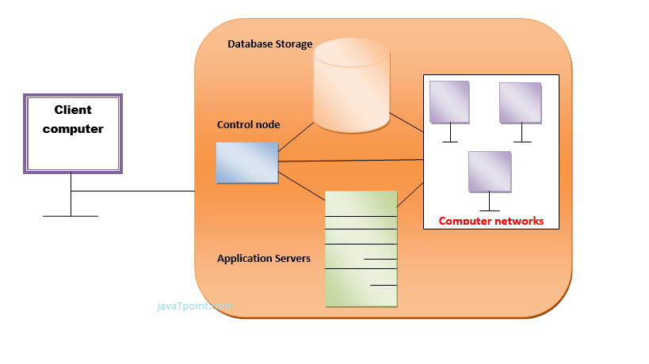

## **Benefits of Cloud Computing Architecture**

The cloud computing architecture is designed in such a way that:

* It solves latency issues and improves data processing requirements
* It reduces IT operating costs and gives good accessibility to access data and digital tools
* It helps businesses to easily scale up and scale down their cloud resources
* It has a flexibility feature which gives businesses a competitive advantage
* It results in better disaster recovery and provides high security
* It automatically updates its services
* It encourages remote working and promotes team collaboration

**RELEVANT READING MATERIAL AND REFERENCES:**

**Source Notes:**

[**https://www.javatpoint.com/cloud-computing-architecture**](https://www.javatpoint.com/cloud-computing-architecture)

**https://www.simplilearn.com/tutorials/cloud-computing-tutorial/cloud-computing-architecture**

Video Lectures:

https://www.youtube.com/watch?v=zl1VgAv5XXI

Text Book Reading:

1. Buyya, Rajkumar, James Broberg, and Andrzej M. Goscinski, eds. Cloud computing: Principles and paradigms. Vol. 87. John Wiley & Sons, 2010.

2. Miller, Michael. Cloud computing: Web-based applications that change the way you work and collaborate online. Que publishing, 2008

**In addition: PPT can be also be given.**

Lecture-6

**Deployment Models of Cloud**

Cloud Deployment Model defines the type of access to the cloud, i.e., how the cloud is located?

Cloud can be access in 4 types:

1. Public Cloud
2. Private Cloud
3. Hybrid Cloud
4. Community Cloud

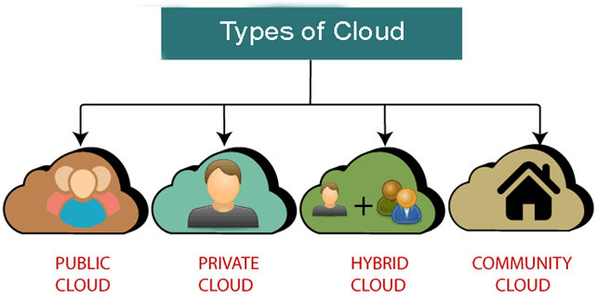

1. **Public Cloud:**

The name speaks for itself, as public clouds are available to the general public and data are created and stored on third-party servers. As server infrastructure belongs to service providers that manage them and administer pool resources, the need for user companies to buy and maintain their own hardware is eliminated. Provider companies offer resources as a service on a free of charge or pay-per-use basis via the Internet connection. Users can scale them when required.

At the same time, relying on a third party in running their infrastructure deprives users of knowing where their information is kept and who has access to it. Often enough, public clouds experience outages and malfunction, as in the case of the  Salesforce CRM disruption in 2016 that caused a 10-hour storage collapse.

The pros of a public cloud are:

* Unsophisticated setup and use
* Easy access to data
* Flexibility to add and reduce capacity
* Cost-effectiveness
* Continuous operation time
* 24/7 upkeep
* Scalability
* Eliminated need for software

The cons of a public model:

* Data security and privacy
* Compromised reliability
* The lack of individual approach

The public cloud deployment model is the first choice of businesses that operate within the industries with low privacy concerns. When it comes to popular cloud deployment models, examples are Amazon Elastic Compute, Google AppEngine, IBM’s Blue, Microsoft Azure, Salesforce Heroku and others.

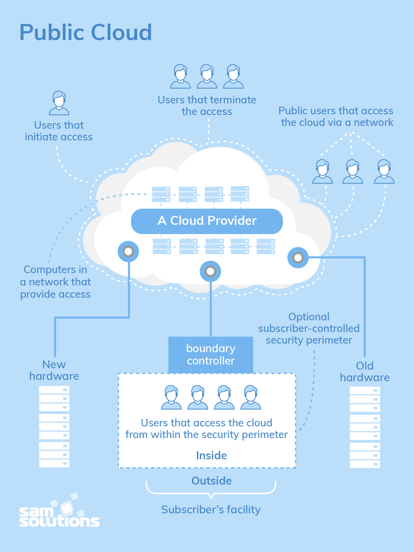

Figure 1: PUBLIC CLOUD

1. **Private Cloud:**

There is little to no difference between public and private clouds from the technical point of view, as their designs are very similar. However, unlike in the public one, only one specific company owns a private cloud, which is why it is also called internal or corporate. Because these data center architectures reside within the firewall, they provide enhanced security. Even though one organization runs its workloads on a private basis, a third party can also manage it, and the server can be hosted externally or on-premises of the user company.

Only a clearly defined scope of persons have access to the information kept in a private repository, preventing the general public from using it. In light of numerous breaches, a growing number of large corporations decided on a closed private type as it is expected to be less risky.

**Advantages of a private model:**

1. Individual development
2. Storage and network components are customizable
3. High control over the corporate information
4. High security, privacy and reliability

**Disadvantages of Private Cloud**

1. Skilled people are required to manage and operate cloud services.
2. Private cloud is accessible within the organization, so the area of operations is limited.
3. Private cloud is not suitable for organizations that have a high user base, and organizations that do not have the prebuilt infrastructure, sufficient manpower to maintain and manage the cloud.

Multiple service providers – including Amazon, IBM, Cisco, Dell and Red Hat – also build private solutions. We at SaM Solutions have created our proprietary cloud solution — CloudBOX. It is a ready-to-use Platform as a Service that facilitates projects by their quick and easy launching.

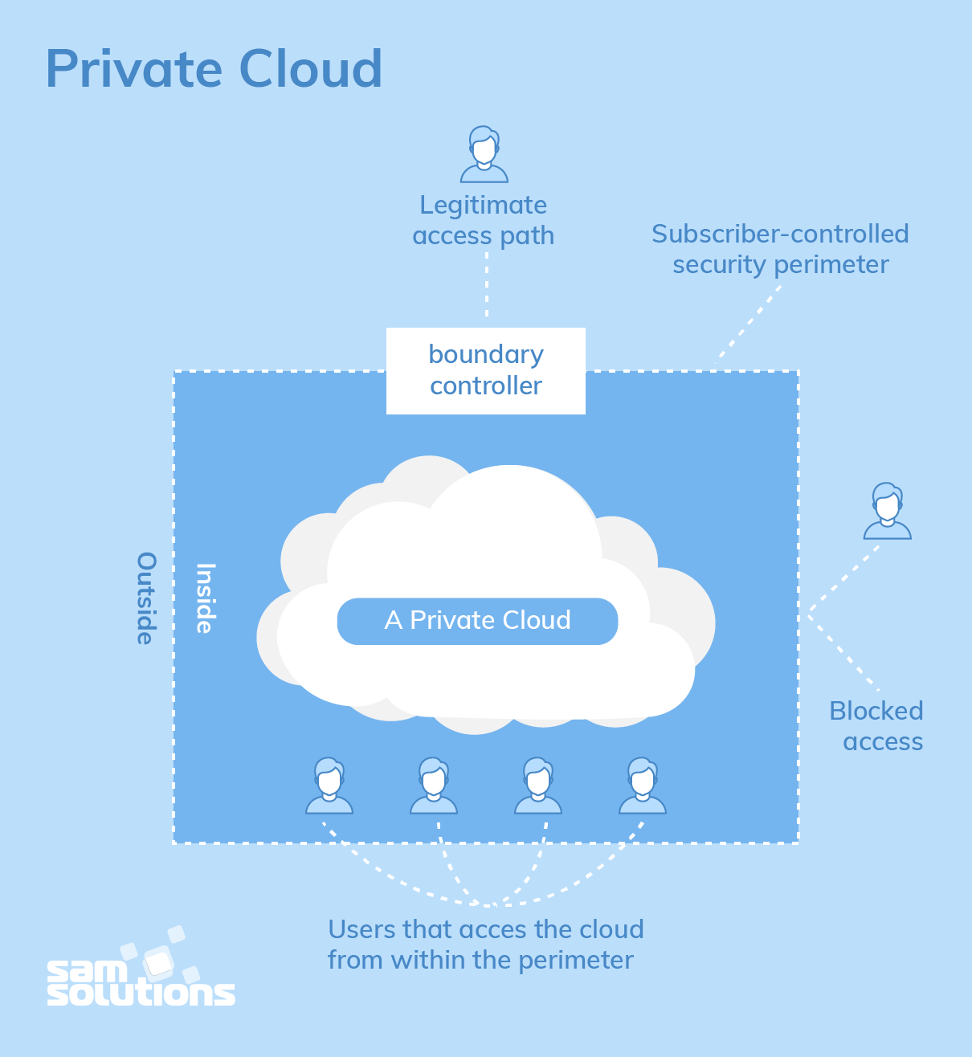

Figure 2: Private Cloud

**RELEVANT READING MATERIAL AND REFERENCES:**

**Source Notes:**

<https://www.javatpoint.com/types-of-cloud>

https://www.geeksforgeeks.org/types-of-cloud/

Video Lectures:

<https://www.youtube.com/watch?v=zRoaSvTeU8E>

<https://www.youtube.com/watch?v=WRUL7JUCFyg>

https://www.youtube.com/watch?v=R07ORNDXGSs

Text Book Reading:

1. Buyya, Rajkumar, James Broberg, and Andrzej M. Goscinski, eds. Cloud computing: Principles and paradigms. Vol. 87. John Wiley & Sons, 2010.

2. Miller, Michael. Cloud computing: Web-based applications that change the way you work and collaborate online. Que publishing, 2008

**In addition: PPT can be also be given.**

Lecture 7

**Deployment Models (continued…)**

**3.Community Cloud:**

A community cloud deployment model resembles a private one to a large extent; the only difference is the set of users. While a private type implies that only one company owns the server, in the case of a community one, several organizations with similar backgrounds share the infrastructure and related resources.

As the organizations have uniform security, privacy and performance requirements, this multi-tenant data center architecture helps companies achieve their business-specific objectives. That is why a community model is particularly suited for organizations that work on joint projects. In that case, a centralized cloud facilitates project development, management and implementation. Also, the costs are shared across all users.

**Advantages of Community Cloud**

There are the following advantages of Community Cloud -

* Community cloud is cost-effective because the whole cloud is being shared by several organizations or communities.
* Community cloud is suitable for organizations that want to have a collaborative cloud with more security features than the public cloud.
* It provides better security than the public cloud.
* It provides collaborative and distributive environment.
* Community cloud allows us to share cloud resources, infrastructure, and other capabilities among various organizations.

**Disadvantages of Community Cloud**

* Community cloud is not a good choice for every organization.
* Security features are not as good as the private cloud.
* It is not suitable if there is no collaboration.
* The fixed amount of data storage and bandwidth is shared among all community members.

Companies can decide on community solutions that Google, Red Hat, IBM, Microsoft or others provide.

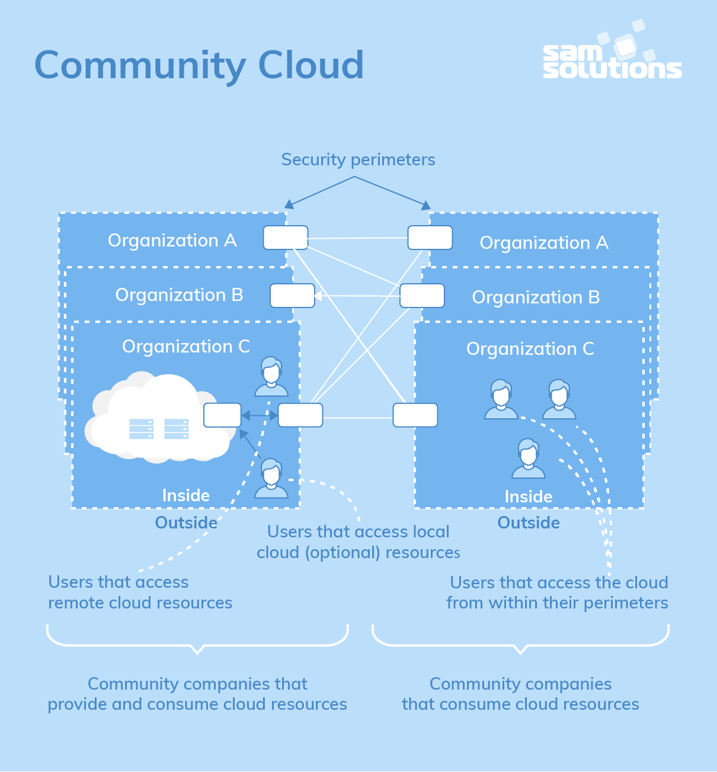

Figure 1: Community Cloud

1. **Hybrid Cloud:**

As it is usually the case with any hybrid phenomenon, a hybrid cloud encompasses the best features of the above-mentioned cloud computing deployment models – a public, private and community ones. It allows companies to mix and match the facets of all three types that best suit their requirements.

As an example, a company can balance its load by locating mission-critical workloads on a secure private cloud and deploying less sensitive ones to a public one. It not only safeguards and controls strategically important assets but does so in the most cost- and resource-effective way possible for each specific case. Also, this approach facilitates data and application portability.

**Advantages of Hybrid Cloud**

There are the following advantages of Hybrid Cloud -

* Hybrid cloud is suitable for organizations that require more security than the public cloud.
* Hybrid cloud helps you to deliver new products and services more quickly.
* Hybrid cloud provides an excellent way to reduce the risk.
* Hybrid cloud offers flexible resources because of the public cloud and secure resources because of the private cloud.

**Disadvantages of Hybrid Cloud**

* In Hybrid Cloud, security feature is not as good as the private cloud.
* Managing a hybrid cloud is complex because it is difficult to manage more than one type of deployment model.
* In the hybrid cloud, the reliability of the services depends on cloud service providers.

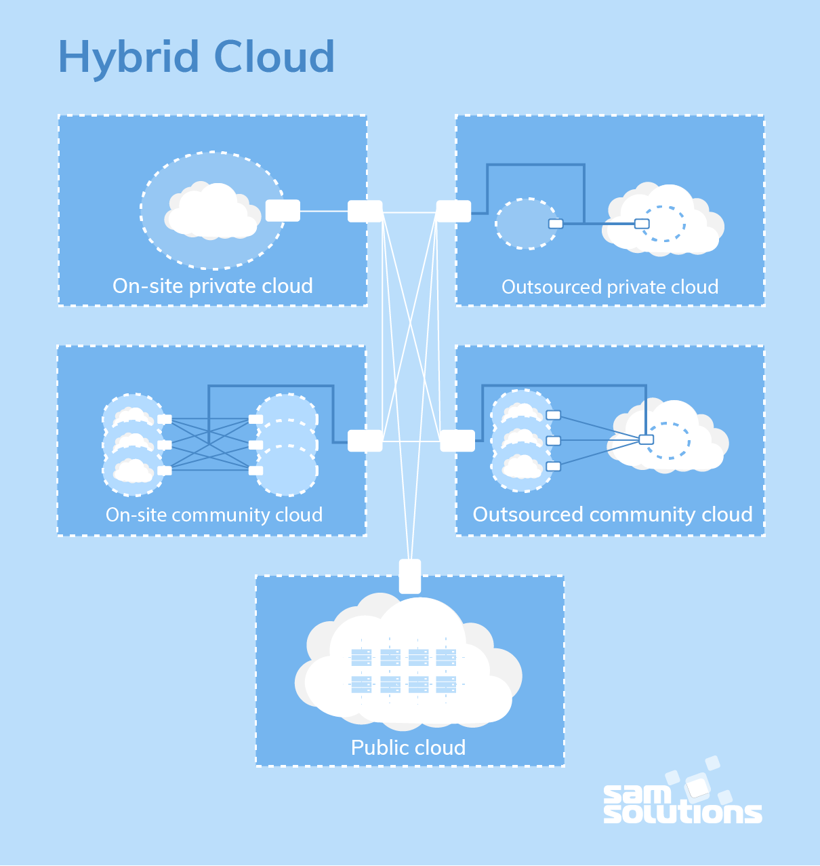

Figure 2: Hybrid Cloud

## **Difference between public cloud, private cloud, hybrid cloud, and community cloud -**

The below table shows the difference between public cloud, private cloud, hybrid cloud, and community cloud.

|  |  |  |  |  |
| --- | --- | --- | --- | --- |
| **Parameter** | **Public Cloud** | **Private Cloud** | **Hybrid Cloud** | **Community Cloud** |
| **Host** | Service provider | Enterprise (Third party) | Enterprise (Third party) | Community (Third party) |
| **Users** | General public | Selected users | Selected users | Community members |
| **Access** | Internet | Internet, VPN | Internet, VPN | Internet, VPN |
| **Owner** | Service provider | Enterprise | Enterprise | Community |

**Benefits of Deployment model:**

* **In Payroll processing:**

Processing time and hardware requirements are reduced as well as elasticity enabled for future expansion.

* **In Astronomic data processing:**

Energy costs and hardware requirements are reduced. Administration is simplified.

* **In Central Government:**

IT expertise consolidates and hardware requirements are reduced.

* **In Local Government:**

IT expertise consolidates and hardware requirements are reduced

**RELEVANT READING MATERIAL AND REFERENCES:**

**Source Notes:**

<https://www.javatpoint.com/types-of-cloud>

https://www.geeksforgeeks.org/types-of-cloud/

Video Lectures:

<https://www.youtube.com/watch?v=WRUL7JUCFyg>

https://www.youtube.com/watch?v=R07ORNDXGSs

**Text Book Reading:**

1. Buyya, Rajkumar, James Broberg, and Andrzej M. Goscinski, eds. Cloud computing: Principles and paradigms. Vol. 87. John Wiley & Sons, 2010.

2. Miller, Michael. Cloud computing: Web-based applications that change the way you work and collaborate online. Que publishing, 2008

**In addition: PPT can be also be given.**

**Lecture-8**

**Services offered by Cloud**

Cloud Computing can be defined as the practice of using a network of remote servers hosted on the Internet to store, manage, and process data, rather than a local server or a personal computer. Companies offering these computing services are called cloud providers and typically charge for cloud computing services based on usage.

**Types of cloud services**

1. Software as a service (Saas)
2. Platform as a service (PaaS)
3. Infrastructure as a service (IaaS)
4. Anything as a service (XaaS)

**1. SOFTWARE AS A SERVICE (SaaS)**

Software-as-a-Service (SaaS) is a way of delivering services and applications over the Internet. Instead of installing and maintaining software, we simply access it via the Internet, freeing ourselves from the complex software and hardware management. It removes the need to install and run applications on our own computers or in the data centers eliminating the expenses of hardware as well as software maintenance.  
SaaS provides a complete software solution which you purchase on a **pay-as-you-go** basis from a cloud service provider. Most SaaS applications can be run directly from a web browser without any downloads or installations required. The SaaS applications are sometimes called **Web-based software, on-demand software, or hosted software.**

## Characteristics

Here are the characteristics of SaaS service model:

* SaaS makes the software available over the Internet.
* The software applications are maintained by the vendor.
* The license to the software may be subscription based or usage based. And it is billed on recurring basis.
* SaaS applications are cost-effective since they do not require any maintenance at end user side.
* They are available on demand.
* They can be scaled up or down on demand.
* They are automatically upgraded and updated.
* SaaS offers shared data model. Therefore, multiple users can share single instance of infrastructure. It is not required to hard code the functionality for individual users.
* All users run the same version of the software.

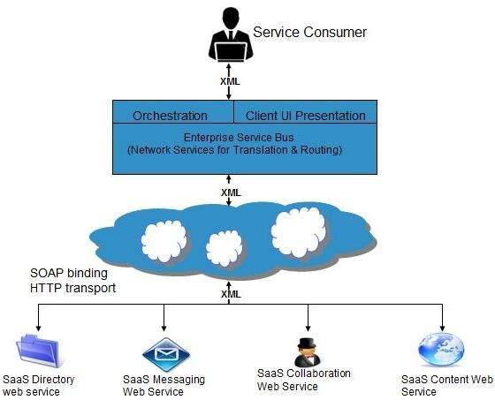

**Advantages of SaaS:**  
1.**Cost Effective:** Pay only for what you use  
2.**Reduced time:** Users can run most SaaS apps directly from their web browser without needing to download and install any software. This reduces the time spent in installation and configuration and can reduce the issues that can get in the way of the software deployment.  
3.**Accessibility:** We can Access app data from anywhere.  
4.**Automatic updates:** Rather than purchasing new software, customers rely on a SaaS provider to automatically perform the updates.  
5.**Scalability:**It allows the users to access the services and features on demand.

## 2. PLATFORM AS A SERVICE (PaaS)

PaaS is a category of cloud computing that provides a platform and environment to allow developers to build applications and services over the internet. PaaS services are hosted in the cloud and accessed by users simply via their web browser.  
A PaaS provider hosts the hardware and software on its own infrastructure. As a result, PaaS frees users from having to install in-house hardware and software to develop or run a new application. Thus, the development and deployment of the application takes place **independent of the hardware**.  
The consumer does not manage or control the underlying cloud infrastructure including network, servers, operating systems, or storage, but has control over the deployed applications and possibly configuration settings for the application-hosting environment.

**Characteristics**

Here are the characteristics of PaaS service model:

* PaaS offers **browser-based development environment.** It allows the developer to create database and edit the application code either via Application Programming Interface or point-and-click tools.
* PaaS provides **built-in security, scalability,** and **web service interfaces.**
* PaaS provides built-in tools for defining **workflow, approval processes,** and business rules.
* It is easy to integrate PaaS with other applications on the same platform.
* PaaS also provides web services interfaces that allow us to connect the applications outside the platform.

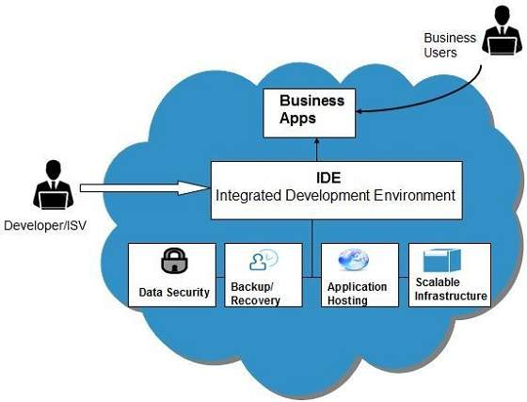

**Advantages of PaaS:**  
1.**Simple and convenient for users:**It provides much of the infrastructure and other IT services, which users can access anywhere via a web browser.  
2.**Cost Effective:**It charges for the services provided on a per-use basis thus eliminating the expenses one may have for on-premises hardware and software.  
3.**Efficiently managing the lifecycle:** It is designed to support the complete web application lifecycle: building, testing, deploying, managing and updating.  
4.**Efficiency:** It allows for higher-level programming with reduced complexity thus, the overall development of the application can be more effective

**RELEVANT READING MATERIAL AND REFERENCES:**

**Source Notes:**

[**https://www.geeksforgeeks.org/cloud-based-services/**](https://www.geeksforgeeks.org/cloud-based-services/)

[**https://www.tutorialspoint.com/cloud_computing/cloud_computing_overview.htm**](https://www.tutorialspoint.com/cloud_computing/cloud_computing_overview.htm)

**Video Lectures:**

<https://www.youtube.com/watch?v=VNYw0KMiJlI>

https://youtu.be/xQ5mBBiTe9Q

**Text Book Reading:**

1. Buyya, Rajkumar, James Broberg, and Andrzej M. Goscinski, eds. Cloud computing: Principles and paradigms. Vol. 87. John Wiley & Sons, 2010.

2. Miller, Michael. Cloud computing: Web-based applications that change the way you work and collaborate online. Que publishing, 2008

**In addition: PPT can be also be given.**

**Lecture -9**

**Services offered by Cloud (Contd..)**

## 3. INFRASTRUCTURE AS A SERVICE (IaaS)

Infrastructure as a service (IaaS) is a service model that delivers computer infrastructure on an outsourced basis to support various operations. Typically, IaaS is a service where infrastructure is provided as an outsource to enterprises such as networking equipment, devices, database and web servers.  
**Infrastructure as a service (IaaS) is also known as Hardware as a service (HaaS).** IaaS customers pay on a per-use basis, typically by the hour, week or month. Some providers also charge customers based on the amount of virtual machine space they use.  
It simply provides the underlying operating systems, security, networking, and servers for developing such applications, services, and for deploying development tools, databases, etc.

## Characteristics

Here are the characteristics of IaaS service model:

* Virtual machines with pre-installed software.
* Virtual machines with pre-installed operating systems such as Windows, Linux, and Solaris.
* On-demand availability of resources.
* Allows to store copies of particular data at different locations.
* The computing resources can be easily scaled up and down.

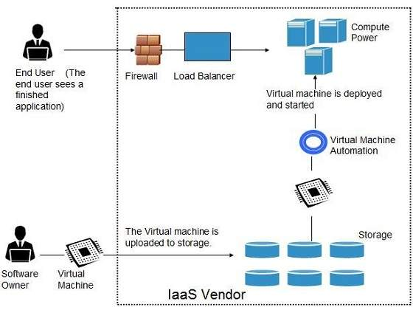

**Advantages of IaaS:**  
1.**Cost Effective:** Eliminates capital expense and reduces ongoing cost and IaaS customers pay on a per use basis, typically by the hour, week or month.  
2.**Website hosting:** Running websites using IaaS can be less expensive than traditional web hosting.  
3.**Security:**The IaaS Cloud Provider may provide better security than your existing software.  
4.**Maintenance:** There is no need to manage the underlying data center or the introduction of new releases of the development or underlying software. This is all handled by the IaaS Cloud Provider.

## 4. Anything AS A SERVICE (XaaS)

Most of the cloud service providers now a day offer anything as a service that is a compilation of all of the above services including some additional services.

Anything as a Service (XaaS) is a cloud computing term for the extensive variety of services and applications emerging for users to access on demand over the Internet.

XaaS term refers to delivery of anything as a service. In this model of cloud computing products, tools and technologies are delivered to users as a service over a network; typically, the Internet, rather than on-premises.

## Example of XaaS

Every single day, many services are getting added in XaaS. The most common encompass the three general cloud computing models: [Software as a Service (SaaS)](https://timesofcloud.com/cloud-tutorial/software-as-a-service-saas/), [Platform as a Service (PaaS)](https://timesofcloud.com/cloud-tutorial/platform-as-a-service-paas/) and [Infrastructure as a Service (IaaS)](https://timesofcloud.com/cloud-tutorial/infrastructure-as-a-service-iaas/).

There are many other examples of XaaS as following.

1. [Network as a Service](https://timesofcloud.com/cloud-tutorial/xaas/)
2. [Storage as a Service](https://timesofcloud.com/cloud-tutorial/xaas/)
3. [Database as a Service](https://timesofcloud.com/cloud-tutorial/xaas/)
4. [Information as a Service](https://timesofcloud.com/cloud-tutorial/xaas/)
5. [Integration as a Service](https://timesofcloud.com/cloud-tutorial/xaas/)
6. [Security as a Service](https://timesofcloud.com/cloud-tutorial/xaas/)
7. [Malware as a Service](https://timesofcloud.com/cloud-tutorial/xaas/)
8. [Disaster Recovery as a Service (DRaaS)](https://timesofcloud.com/cloud-tutorial/xaas/)
9. [Communications as a Service](https://timesofcloud.com/cloud-tutorial/xaas/)

**Advantages of XaaS:**  
All of the above advantages

**RELEVANT READING MATERIAL AND REFERENCES:**

**Source Notes:**

[**https://www.geeksforgeeks.org/cloud-based-services/**](https://www.geeksforgeeks.org/cloud-based-services/)

[**https://www.tutorialspoint.com/cloud_computing/cloud_computing_overview.htm**](https://www.tutorialspoint.com/cloud_computing/cloud_computing_overview.htm)

**https://timesofcloud.com/cloud-tutorial/xaas/**

**Video Lectures:**

https://www.youtube.com/watch?v=N8d_ZvFJf-g

**Text Book Reading:**

1. Buyya, Rajkumar, James Broberg, and Andrzej M. Goscinski, eds. Cloud computing: Principles and paradigms. Vol. 87. John Wiley & Sons, 2010.

2. Miller, Michael. Cloud computing: Web-based applications that change the way you work and collaborate online. Que publishing, 2008

**In addition: PPT can be also be given.**

**Lecture -9**

**Benefits and Limitations of Cloud Computing**

**Benefits:**

Cloud Computing is an emerging technology that almost every company is being switched to from its on-premise technologies. Whether it is public, private, or hybrid, Cloud Computing has become an essential factor for companies to rise up to the competition. Let us find out why the cloud is so much preferred over the on-premise technologies.

* **Cost efficiency:**The biggest reason behind companies shifting to Cloud Computing is that it takes considerably lesser cost than any on-premise technology. Now, companies need not store data in disks anymore as the cloud offers enormous storage space, saving money and resources.
* **High speed:**Cloud Computing lets us deploy the service quickly in fewer clicks. This quick deployment lets us get the resources required for our system within minutes.
* **Excellent accessibility:**Storing information in the cloud allows us to access it anywhere and anytime regardless of the machine making it a highly accessible and flexible technology of the present times.
* **Back-up and restore data:**Once data is stored in the cloud, it is easier to get its back-up and recovery, which is quite a time-consuming process in on-premise technology.
* **Manageability:**Cloud Computing eliminates the need for IT infrastructure updates and maintenance since the service provider ensures timely, guaranteed, and seamless delivery of our services and also takes care of all the maintenance and management of our IT services according to the service-level agreement (SLA).
* **Sporadic batch processing:**Cloud Computing lets us add or subtract resources and services according to our needs. So, if the workload is not 24/7, we need not worry about the resources and services getting wasted and we won’t end up stuck with unused services.
* **Strategic edge:**Cloud Computing provides a company with a competitive edge over its competitors when it comes to accessing the latest and mission-critical applications that it needs without having to invest its time and money on their installations. It lets the company focus on keeping up with the business competition by offering access to the most trending and in-demand applications and doing all the manual work of installing and maintaining the applications for the company.

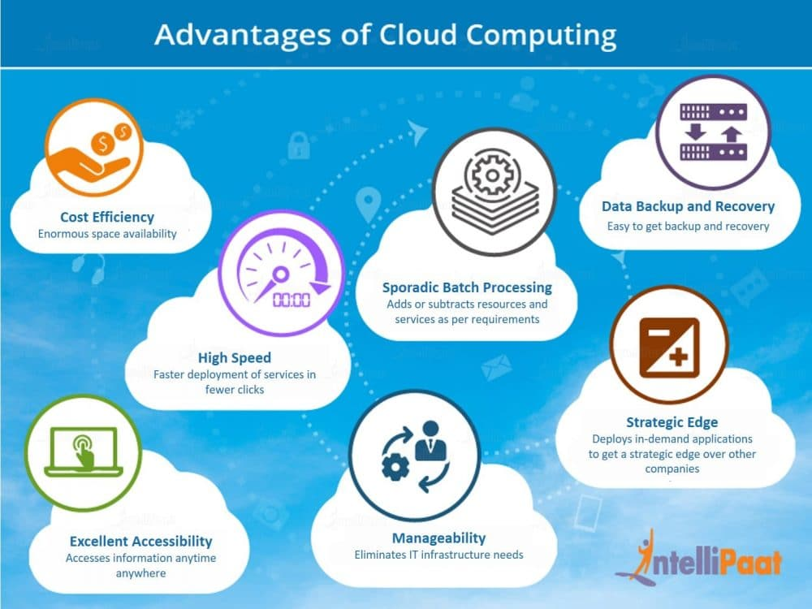

**Limitations:**

Every technology has both positive and negative aspects that are highly important to be discussed before implementing it. The aforementioned points highlight the benefits of using cloud technology and the following discussion will outline the potential cons of Cloud Computing.

* **Vulnerability to attacks:**Storing data in the cloud may pose serious challenges of information theft since in the cloud every data of a company is online. Security breach is something that even the best organizations have suffered from and it’s a potential risk in the cloud as well. Although advanced security measures are deployed on the cloud, still storing confidential data in the cloud can be a risky affair.
* **Network connectivity dependency:**Cloud Computing is entirely dependent on the Internet. This direct tie-up with the Internet means that a company needs to have reliable and consistent Internet service as well as a fast connection and bandwidth to reap the benefits of Cloud Computing.
* **Downtime:**Downtime is considered as one of the biggest potential downsides of using Cloud Computing. The cloud providers may sometimes face technical outages that can happen due to various reasons, such as loss of power, low Internet connectivity, data centers going out of service for maintenance, etc. This can lead to a temporary downtime in the cloud service.
* **Vendor lock-in:**When in need to migrate from one cloud platform to another, a company might face some serious challenges because of the differences between vendor platforms. Hosting and running the applications of the current cloud platform on some other platform may cause support issues, configuration complexities, and additional expenses. The company data might also be left vulnerable to security attacks due to compromises that might have been made during migrations.
* **Limited control:**Cloud customers may face limited control over their deployments. Cloud services run on remote servers that are completely owned and managed by service providers, which makes it hard for the companies to have the level of control that they would want over their back-end infrastructure.

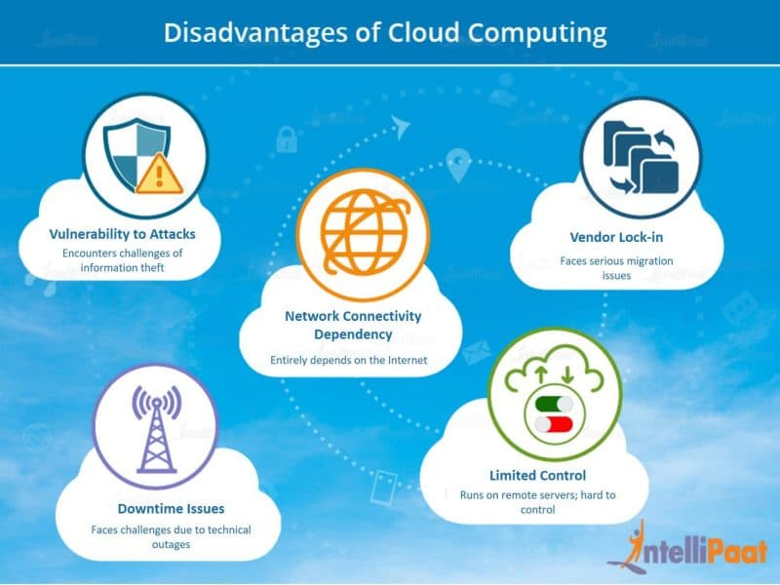

**RELEVANT READING MATERIAL AND REFERENCES:**

**Source Notes:**

**https://intellipaat.com/blog/tutorial/amazon-web-services-aws-tutorial/advantages-and-disadvantages-of-cloud-computing/**

**https://www.guru99.com/advantages-disadvantages-cloud-computing.html**

Video Lectures:

https://www.youtube.com/watch?v=N8d_ZvFJf-g

Text Book Reading:

1. Buyya, Rajkumar, James Broberg, and Andrzej M. Goscinski, eds. Cloud computing: Principles and paradigms. Vol. 87. John Wiley & Sons, 2010.

2. Miller, Michael. Cloud computing: Web-based applications that change the way you work and collaborate online. Que publishing, 2008

**In addition: PPT can be also be given.**

**Lecture-10**

**Risks Related to Cloud Computing**

Cloud Computing is a new name for an old concept. The delivery of computing services from a remote location. Cloud Computing is Internet-based computing, where shared resources, software, and information are provided to computers and other devices on demand.

These are major issues in Cloud Computing:

**Privacy:**

The user data can be accessed by the host company with or without permission. The service provider may access the data that is on the cloud at any point in time. They could accidentally or deliberately alter or even delete information.

**Compliance:**

There are many regulations in places related data and hosting. To comply with regulations (Federal Information Security Management Act, Health Insurance Portability and Accountability Act, etc.) user may have to adopt deployment modes that are expensive.

**Security:**

Cloud-based services involve third-party for storage and security. Can one assume that a cloud-based company will protect and secure one’s data if one is using their services at a very low or for free? They may share user’s information with others. Security presents a real threat to cloud.

**Sustainability:**

This issue refers to minimizing the effect of cloud computing on environment. Citing the server’s effects on the environmental effects of cloud computing, in areas where climate favors natural cooling and renewable electricity is readily available, the countries with favorable conditions, such as Finland, Sweden, and Switzerland are trying to attract cloud computing data centers. But other than nature’s favors, would these countries have enough technical infrastructure to sustain the high-end clouds?

**Abuse:**

While providing cloud services, it should be ascertained that the client is not purchasing the services of cloud computing for nefarious purpose. In 2009, a banking Trojan illegally used the popular Amazon service as a command and control channel that issued software updates and malicious instruction to PCs that were infected by the malware.

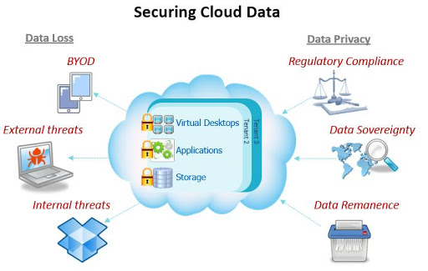

**Cloud Computing and Virtualization**

The main enabling technology for Cloud Computing is Virtualization. Virtualization is a partitioning of single physical server into multiple logical servers. Once the physical server is divided, each logical server behaves like a physical server and can run an operating system and applications independently. Many popular companies’ like VMware and Microsoft provide virtualization services, where instead of using your personal PC for storage and computation, you use their virtual server. They are fast, cost-effective and less time consuming.

For software developers and testers virtualization comes very handy, as it allows developer to write code that runs in many different environments and more importantly to test that code.

## **How Virtualization Works in Cloud**

Virtualization plays a significant role in cloud technology and its working mechanism. Usually, what happens in the cloud - the users not only share the data that are located in the cloud-like application but also share their infrastructures with the help of virtualization. Virtualization is used mainly to provide applications with standard versions for cloud customers. With the release of the latest version of an application, the providers can efficiently provide that application to the cloud and its users, and it is possible using virtualization only. By using this virtualization concept, all servers & software other cloud providers require those are maintained by a third-party, and the cloud provider pays them on a monthly or yearly basis.

In reality, most of today's hypervisors use a combination of different types of hardware virtualization. Mainly virtualization means running multiple systems on a single machine but sharing all resources (hardware) & it helps to share IT resources to get benefits in the business field.

## **Features of Virtualization**

1. **Partitioning**: Multiple virtual servers can run on a physical server at the same time.
2. **Encapsulation of data**: All data on the virtual server, including boot disks, is encapsulated in a file format.
3. **Isolation**: The Virtual server running on the physical server is safely separated and don't affect each other.
4. **Hardware Independence**: When the virtual server runs, it can migrate to a different hardware platform.

## **Advantages of Virtualization**

* The number of servers gets reduced by the use of the virtualization concept.
* Improve the ability of technology.
* The business continuity was also raised due to the use of virtualization.
* It creates a mixed virtual environment.
* Increase efficiency for the development and test environment.
* Lowers Total Cost of Ownership (TCO).

**Use of Virtualization**

Virtualization is mainly used for three main purposes

1. Network Virtualization
2. Server Virtualization
3. Storage Virtualization

**RELEVANT READING MATERIAL AND REFERENCES:**

**Source Notes:**

<https://www.geeksforgeeks.org/issues-in-cloud-computing/>

<https://www.calyptix.com/research-2/top-5-risks-of-cloud-computing/>

[**https://www.javatpoint.com/virtualization-in-cloud-computing**](https://www.javatpoint.com/virtualization-in-cloud-computing)

**Video Lectures:**

<https://www.youtube.com/watch?v=7Ey_ABmbkok>

**Text Book Reading:**

1. Buyya, Rajkumar, James Broberg, and Andrzej M. Goscinski, eds. Cloud computing: Principles and paradigms. Vol. 87. John Wiley & Sons, 2010.

2. Miller, Michael. Cloud computing: Web-based applications that change the way you work and collaborate online. Que publishing, 2008

**In addition: PPT can be also be given.**

**Lecture-11**

**Types of Virtualization**

1. Hardware Virtualization.
2. Operating system Virtualization.
3. Server Virtualization.
4. Storage Virtualization.

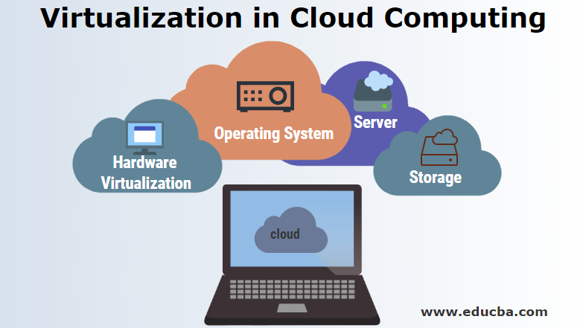

**1) Hardware Virtualization:**

When the virtual machine software or virtual machine manager *(VMM) is directly installed on the hardware system* is known as hardware virtualization. The main job of hypervisor is to control and monitoring the processor, memory and other hardware resources. After virtualization of hardware system, we can install different operating system on it and run different applications on those OS.

**Usage:**

Hardware virtualization is mainly done for the server platforms, because controlling virtual machines is much easier than controlling a physical server.

**Advantages of Hardware Virtualization**

The benefits of hardware virtualization decrease the overall cost of cloud users and increase flexibility.  
The advantages are:

* **Lower Cost:** Because of server consolidation, the cost decreases; now, multiple OS can exist together in a single hardware. This minimizes the quantity of rack space, reduces the number of servers, and eventually drops the power consumption.
* **Efficient resource utilization:** Physical resources can be shared among virtual machines. Another virtual machine can use the unused resources allocated by one virtual machine in case of any need.
* **Increase IT flexibility:**The quick development of hardware resources became possible using virtualization, and the resources can be managed consistently also.
* **Advanced Hardware Virtualization features:**With the advancement of modern hypervisors, highly complex operations maximize the abstraction of hardware & ensure maximum uptime. This technique helps to migrate an ongoing virtual machine from one host to another host dynamically.

**2) Operating System Virtualization:**

When the virtual machine software or virtual machine manager *(VMM) is installed on the Host operating system* instead of directly on the hardware system is known as operating system virtualization.

**Usage:**

Operating System Virtualization is mainly used for testing the applications on different platforms of OS.

**How OS Virtualization Works**

The steps for how these virtualization works are listed below:

* Connect to OS Virtualization Server
* Connect to virtual disk
* Then connect this virtual disk to the client
* OS is streamed to the client
* If further additional streaming is required, it is done

**Advantages of OS Virtualization**

* OS virtualization usually imposes little or no overhead.
* OS Virtualization is capable of live migration
* It can also use dynamic load balancing of containers between nodes and a cluster.

**3) Server Virtualization:**

When the virtual machine software or virtual machine manager *(VMM) is directly installed on the Server system* is known as server virtualization.

**Usage:**

Server virtualization is done because a single physical server can be divided into multiple servers on the demand basis and for balancing the load.

**Advantages of Server Virtualization**

* **Cost Reduction:** Server virtualization reduces cost because less hardware is required.
* **Independent Restart:** Each server can be rebooted independently and that reboot won't affect the working of other virtual servers.

**4) Storage Virtualization:**

Storage virtualization is the *process of grouping the physical storage from multiple network storage devices so that it looks like a single storage device*.

Storage virtualization is also implemented by using software applications.

**Usage:**

Storage virtualization is mainly done for back-up and recovery purposes.

**Advantages of Storage Virtualization**

* Data is stored in a very convenient location. This is because if the host failure data don't get compromised necessarily.
* By using storage level abstraction, it becomes flexible how storage is provided, protected, partitioned and used.
* Storage Devices are capable of performing advanced functions such as disaster recovery, duplication, replication of data & re-duplication of data.

**RELEVANT READING MATERIAL AND REFERENCES:**

**Source Notes:**

[**https://www.javatpoint.com/virtualization-in-cloud-computing**](https://www.javatpoint.com/virtualization-in-cloud-computing)

**https://www.geeksforgeeks.org/virtualization-cloud-computing-types/**

**Video Lectures:**

https://www.youtube.com/watch?v=nI9x3gUvhEI

**Text Book Reading:**

1. Buyya, Rajkumar, James Broberg, and Andrzej M. Goscinski, eds. Cloud computing: Principles and paradigms. Vol. 87. John Wiley & Sons, 2010.

2. Miller, Michael. Cloud computing: Web-based applications that change the way you work and collaborate online. Que publishing, 2008

**In addition: PPT can be also be given.**